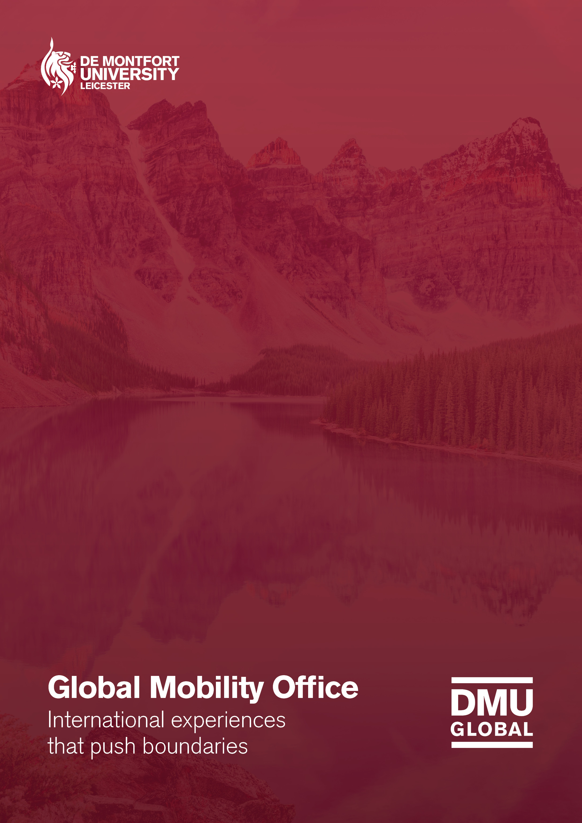

DMU Global Student Learning Log

Introduction

DMU Global international experiences will help you to develop a range of skills and competencies, as well as enhancing your studies and cultural awareness. The value you get from your experience, however, is largely determined by the quality of your reflections and your ability to apply gained skills and knowledge in the future.

The aim of this document is to provide you with practical tools and guidance that will allow you to log your learning during your experience. It will cover the following topics (we suggest that you follow the order below):

1. Goal setting
Make the most of your experience through goal setting

2. Learning log
A place to help you record your learning

3. The STAR technique
Learn how to articulate answers to application or interview questions

4. Developing and articulating transferable skills
Insights into how you can capture examples of skills you developed

1. Goal setting

This section will help you set goals related to your DMU Global experience using a simple framework to organise your thoughts. This is intended as a starting point, and your goals/aims may change as you progress; therefore, we encourage you to revisit and update your goals as continue on your journey.

For this activity:

- Think of any long-term goals or specific objectives you would like to meet, that link to your overseas experience. It can be career-related, academic or personal.
- Think of short-term goals and note specific activities or actions you will take that will help you move towards meeting your long-term goals.
- Consider how your DMU Global experience will be able to assist you in achieving your goals. Think about particular activities participating in, networks you would like to develop and culture-related learning.
- Note all of the above in the table provided.

Long term goals | Short term goals | How the DMU Global trip can help me achieve this goal?

2. Learning log

This learning log is designed to help you record activities that you take part in, what you observe or learn during your overseas trip, and plan any follow up actions.

For this activity:

- Take 5 minutes each day to reflect upon the activities that you have taken part in
- Complete table below by including key activities, ideas, personal observations and thoughts about your learning
- Note things you may want to follow up on
- Revisit your notes after the trip and plan next steps for the things you need to follow up on
Day | Activity | Ideas, learning and observations | What I would like to follow up on

3. The STAR technique

During an interview you may be asked to elaborate on your skills and experience by giving specific examples. The key to giving a good answer is structure, and by using the STAR technique you can achieve just that. Use the space below to write an example from your experience.
Result
Explain the outcome of the action you took. Highlight the successes, achievements or/and improvements gained as a result of your actions.
Action
Describe what you did in response to the task. Ideally, you will want to address:
- What you did
- Why you did it
- How you did it

Task
Describe the task and what was required of you. Make sure you are clear and concise about what the exact challenge was and what you needed to do in response.
Situation
Provide a description of the situation you were in. Think of it as setting the scene; where were you? What were you doing? Who else was involved?

Situation | Task | Action | Result

4. Developing your transferable skills

The skills matrix provided below gives you a structure to capture and articulate examples of how you have developed a certain skill or competency. Utilising your experiences from a DMU Global opportunity is a great way to showcase your international experience, as well as providing meaningful, interesting and real-life examples of skills you have developed. These examples can be used alongside the STAR technique to create stories of your skills and experience for your CV, job applications and interviews.

Skills Inventory | Evidence for this skill | How I will develop this skill further
Cultural Agility
Able to understand the perspectives of individuals from different cultures and backgrounds and to empathise with these views, and respond to them. The ability to cope with and adapt to living in different environments.
Networking
Establish and maintain working and communicative relationships with others to support and further their own objectives, identify role models and develop a professional identity.
Interpersonal skills
The ability to relate to and feel comfortable with people at all levels, to be able to make and maintain relationships as circumstances change, to be able to demonstrate active listening.
Adaptability and Flexibility
Able to manage change in an adaptable and flexible manner. Ability to ‘think on feet’ and change styles in different situations.
Oral/Written communication
Able to communicate formally and informally, verbally and in the written form, with a wide range of people, both internal and external of the organization.
Resilience
Ability to cope with a crisis, withstand adversity and bounce back from difficult
situations quickly.
Commercial Awareness
An understanding of appropriate relationships with a wide range of individuals, commercial and political awareness in a work context.
Self-Awareness
Awareness of personal characteristics and traits. Ability to identify and articulate own strengths, weaknesses and values.
Commercial Awareness
An understanding of appropriate relationships with a wide range of individuals, commercial and political awareness in a work context.
Other (include other skills that have not been mentioned above)

